Level Design Document

My game takes place in outer space in an alien galaxy where your main objective is to travel in this galaxy and trying to survive against an entire battle ships who are hunting you. The level is composed from many elements which will mostly form a solar system that represents a different sector of the entire galaxy. For now, there will only be one level which will represent the demo of my game. The layout of this first level, consists of an alien space background which has also included 3D elements which I’ve designed them in Blender 2.8 app and which have the role to increase the good design of an alien space level.

This represents the background of my game. This was a picture designed by me in Photoshop. The entire background will be clearer when you are going to play this level of my game. Moreover, for a better design of my background I used different paint colour tools in Photoshop so that I could include a beautiful Nebula. Thus, the level design will be more similar with an alien space from another galaxy.
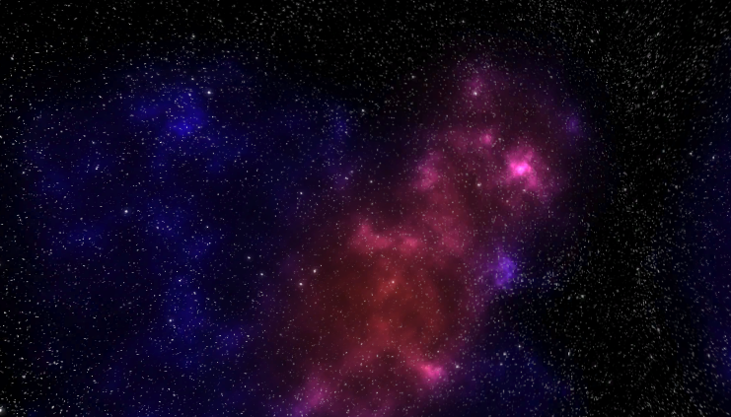
Figure 1:Level Background

Next, for the rest design of my level, I’ve created and added planets but also a sun to form an entire solar system. The player will travel by each of these planets. Of course, since that the entire action of this game takes place in outer space the planets will just be added as a good design of each level (you can’t land on them). For the planets, they represent 3D spheres of different sizes put in different corners of the level. They also have included specific textures which represent different planet texture images taken from the Internet.
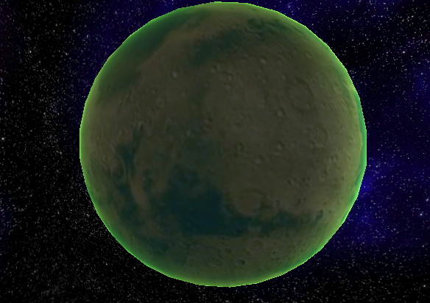
Figure 2:Planet 1

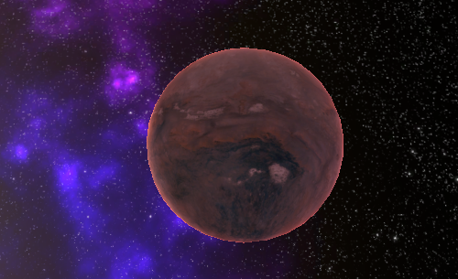
Figure 3:Planet 2

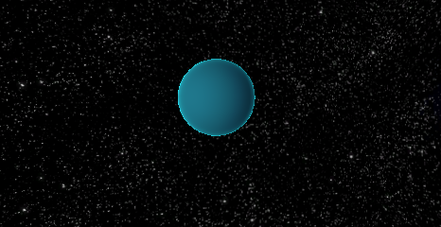
Figure 4:Planet 3

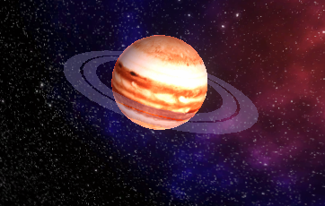
Figure 5:Planet 4
This planet has also attached 2 transparent circles which form a ring around the planet

Moreover, for the design of this level there will also be included a sun as the centre of this solar system. You cannot get close to it. It will also be included to enhance the design of my game.

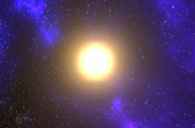
Figure 6:Sun

The player character will consist of an alien ship which was taken from an internet web site. This ship is an element from another video game (Halo series). I considered this could be a good design example for my game since that players now have the opportunity, to experience with this ship in a completely different type of level. The ship will have attached light for a good design but also laser particles to the 2 canons in front of it. Thus, the player can shoot all enemies using these particles attached to each cannon. The lights and cannon particles will be seen during the gameplay.

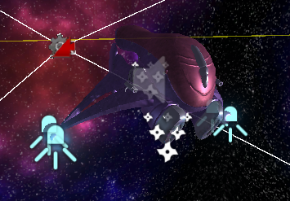
Figure 7:Player Ship

The enemies of this level are 3 different type of ships which they have been taken from resources of an Udemy course from where I studied to make this game. Each enemy represents a different level. By different level, I mean each one has a certain health and score. By this, the second type of ship will be more difficult to destroy it than the first one and the third one more difficult than the first and second. Moreover, if the player will manage to destroy the ships with higher level, that means of course the player will gain higher score. The ships with higher level will appear rarely than the ones with low level (the highest one most rarely). That could make the game more interesting to acquire a good score. The enemies will appear in front of the player to a certain distance. They will also look to the player and trying to shoot him with their lasers. After a few seconds time the enemy ships will leave (and destroy when they are not anymore in the player’s field of view) and new ones will come. That means the player will not be able always to destroy all enemy ships which that could bring of course to a lower score. Besides this the enemy ships will also have a special moving animation made in Unity (move a little bit to left and right repetitive). Thus, the ships will be in continuously movement so that it will not be so easy for player to shoot them. The animation for these enemy ships can be remarked when you will test the game.

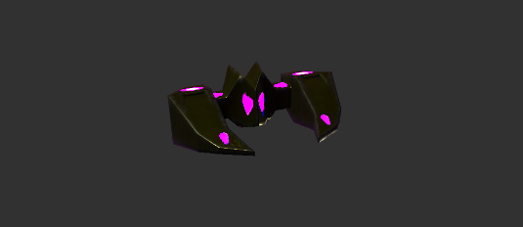
Figure 8:Enemy Ship 1

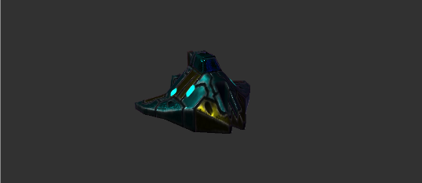
Figure 9:Enemy Ship 2

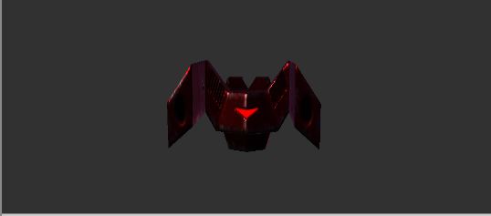
Figure 10:Enemy Ship 3
As the way the player interacts with the game is that the player will automatically follow an entire route on different corners of this level. By this road, the player will have the possibility to see piece by piece the entire design of this level. The enemies will spawn at different points of this road. When player reach to another point the remaining enemies will live and new ones will come to attack the player. The score will depend on how many ships you destroyed and what ships on what level you have destroyed.
Besides enemies the player will have to avoid different field of asteroids as obstacles. The impact with them will make you lose a big amount of your health. Besides this, if you hit an asteroid the player ship will stand still for a few seconds (you will not be able to move for a very short time). That’s why the challenge of surviving during this level will become more difficult since that you have to avoid both obstacles and enemies’ shootings.
Here is presented an example of an asteroids field:

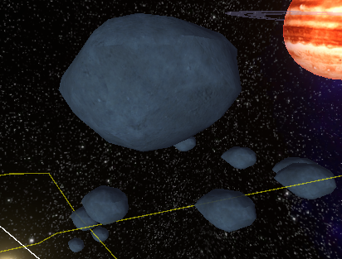
Figure 11:Asteroids field

Here is also an image as an example of player interaction with the level:
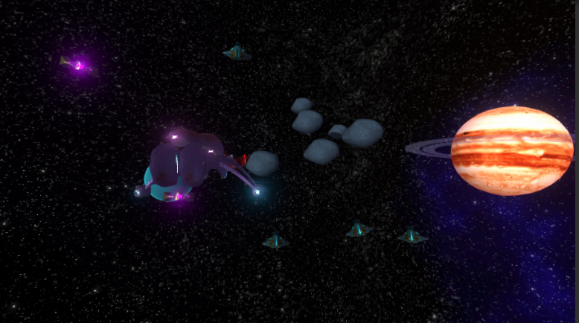
Figure 12:Player Interaction

One more additional design for the level was to include in the scene a huge model of ship which will be put as the mother ship. The player will travel next by this ship and he will have the opportunity to see its entire design. The player is small compared with this big mother ship. This ship was entirely made by me using Blender 2.8 for modelling and Substance Painter for adding metal texture. The ship was only put for a better design of this entire level.

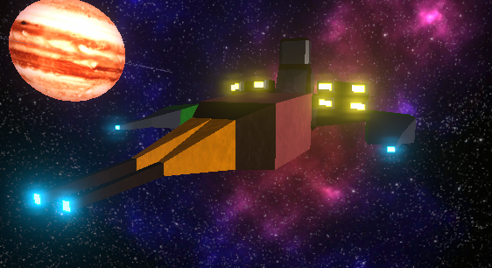
Figure 13:Mother Ship

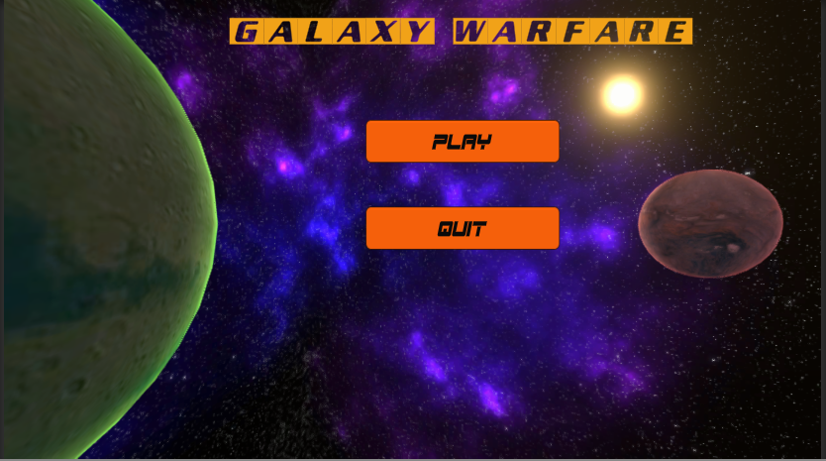
Figure 14:Main Menu
This will represent the Main Menu of my game. For now, you can just play the level or quit the entire game.
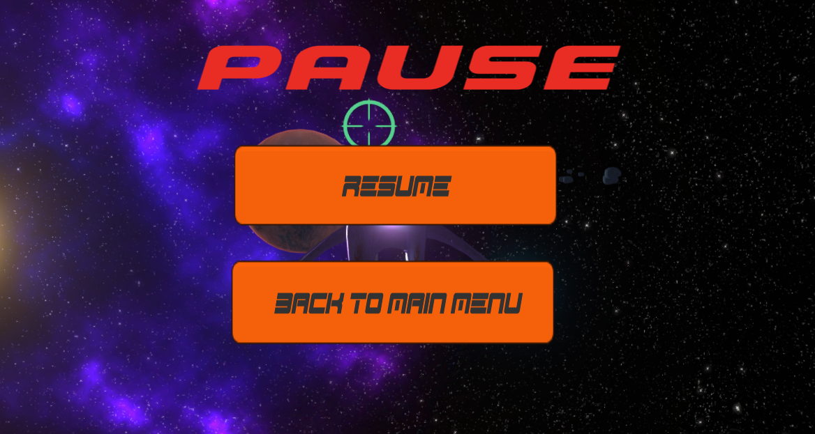
Figure 15:Pause Menu
And this will represent the Pause Menu of my game (by pressing the Esc button).

Las but not least, I’ve also created a game over menu which will appear when player died. You can just try again the level or go back to the main menu.

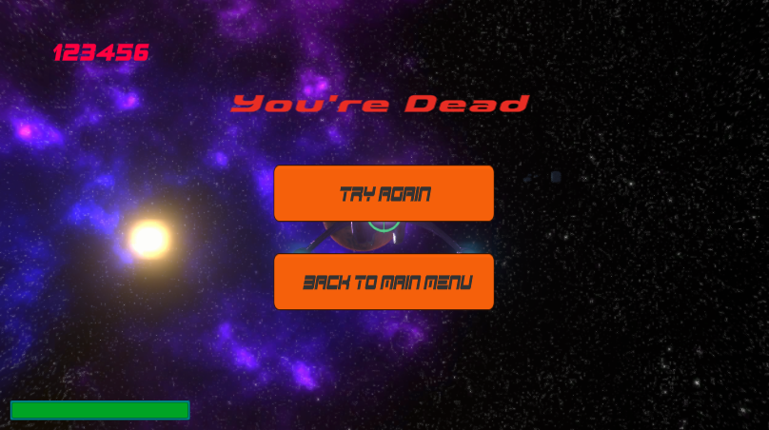
Figure 16:Lose Menu

As for the gameplay, the player will only can move up/down and left/right by using the basic keyboard buttons for moving (W, A, D, S) and also moving the fire target using the mouse and press Mouse 1 button or hold it to fire your cannons. The player ship has also an animation for rotating a little bit the ship up/down or left/right every time when you either move the ship using the moving keyboard buttons or even when you’re moving the fire target using the mouse. The animation can be seen during the play test.

This level has also included different sounds depending on the actions that happens in this game (enemy or player shooting, explosions, ship damage, etc). The level has also a specific soundtrack which represent a music took from an old game (Ratchet and Clank Tools of Destruction). I’ve always considered that this level of my game has some similarities with a certain mission from “Ratchet and Clank” game and that’s why I’ve considered this soundtrack the best choice for my game.
Here down are some links of the web sites from where I searched for sound effects
https://www.zapsplat.com/sound-effect-category/explosions/
https://freesound.org/people/aidave/downloaded_sounds/
For the soundtrack (music) I’ve just copied the link with the video of that music from YouTube and put it on Unity.
https://www.youtube.com/watch?v=bL2kkAt3OJ0&list=PLwxLlSv5mvIZ1xJ1cGge1Z2IeLgpzev02&index=34

Here is a picture of my entire design of this level. Ignore the lines from the picture. They are just components for my game mechanics.
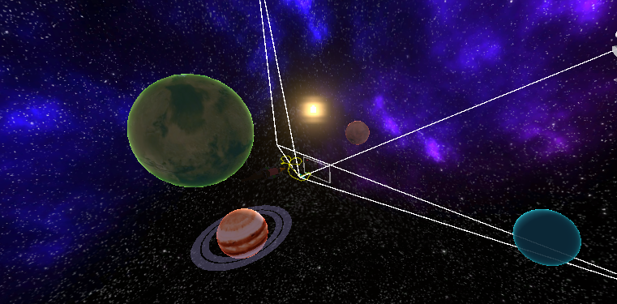
Figure 17:Level Design

So that will represent the design of the first level of my game. During the play, the player will have to survive against the challenges of this level, but also trying to acquire the best score that he could gain. Also, I consider that the design of this level will increase the player’s desire to be included new levels with different enemies and elements in the future.

